**User Manual**

This user manual is for users to use as reference when using this app. This manual will explain about each buttons available and about all the contents available in this app.

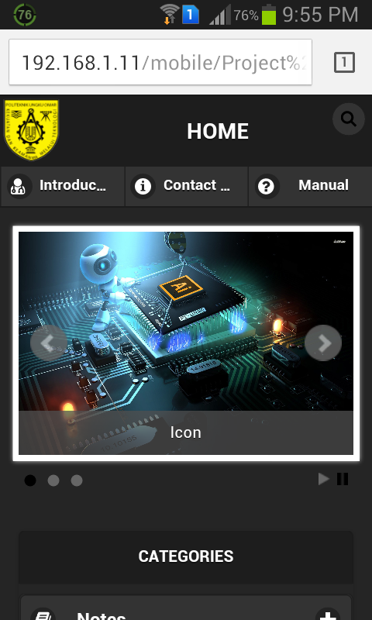

Header

Navigation bar

Slideshow Banner

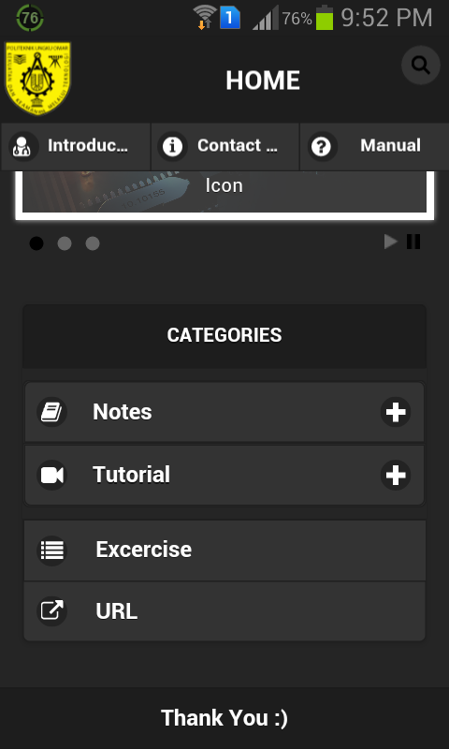

Categories section

1. Header

This is the top section where the search button is located at the top left, clicking on it will show the search panel for easier searching of items. This search button is only seen on the main page and is replaced by the “Home” button when you are on other pages.

1. Navigation Bar

On this bar, the introduction, contact us and manual tab are located. The introduction tab shows information regarding Desktop Publishing. The contact us tab shows our contact info for users to contact us for any inquiries regarding the app. The manual tab is where the download link for the manual for using this app is located.

1. Slideshow banner

This slideshow shows the banner for this app, the code for the subject Desktop publishing and the name and info of the members of the group OMEGA.

1. Categories section

There are four parts in the category section :

* Notes

The notes can be found under this section

* Tutorial section

The tutorial videos can be found under this section

* Exercise

Exercises for self-practice can be found under this section

* URL

The download links for applications such as photoshop and adobe illustrator can be found under this section.